## Overview

It’s time to apply that typography knowledge you learned in the UI section of the course. In this activity, you’ll add a font from Google Fonts to your page so you can create layouts with beautiful typography.

Why? Well, a browser’s default font generally leaves something to be desired. Don’t fret, [Google Fonts](https://fonts.google.com/) hosts almost 1,000 fonts that are available to use on your webpage.

## Instructions

**Part 1: Add Custom Fonts**

1. Open index.html.
   * It’s located in the Unit 17 Activities folder, inside **17.2_unsolved.zip**.
2. Visit [Google Fonts](https://fonts.google.com) and search for the **Open Sans** font. Select the font by clicking the + button.
3. Open the selected styles shelf on the right. You will find an embed tab. Copy the <link> tag and the font-family CSS property to apply your selected font to your webpage:

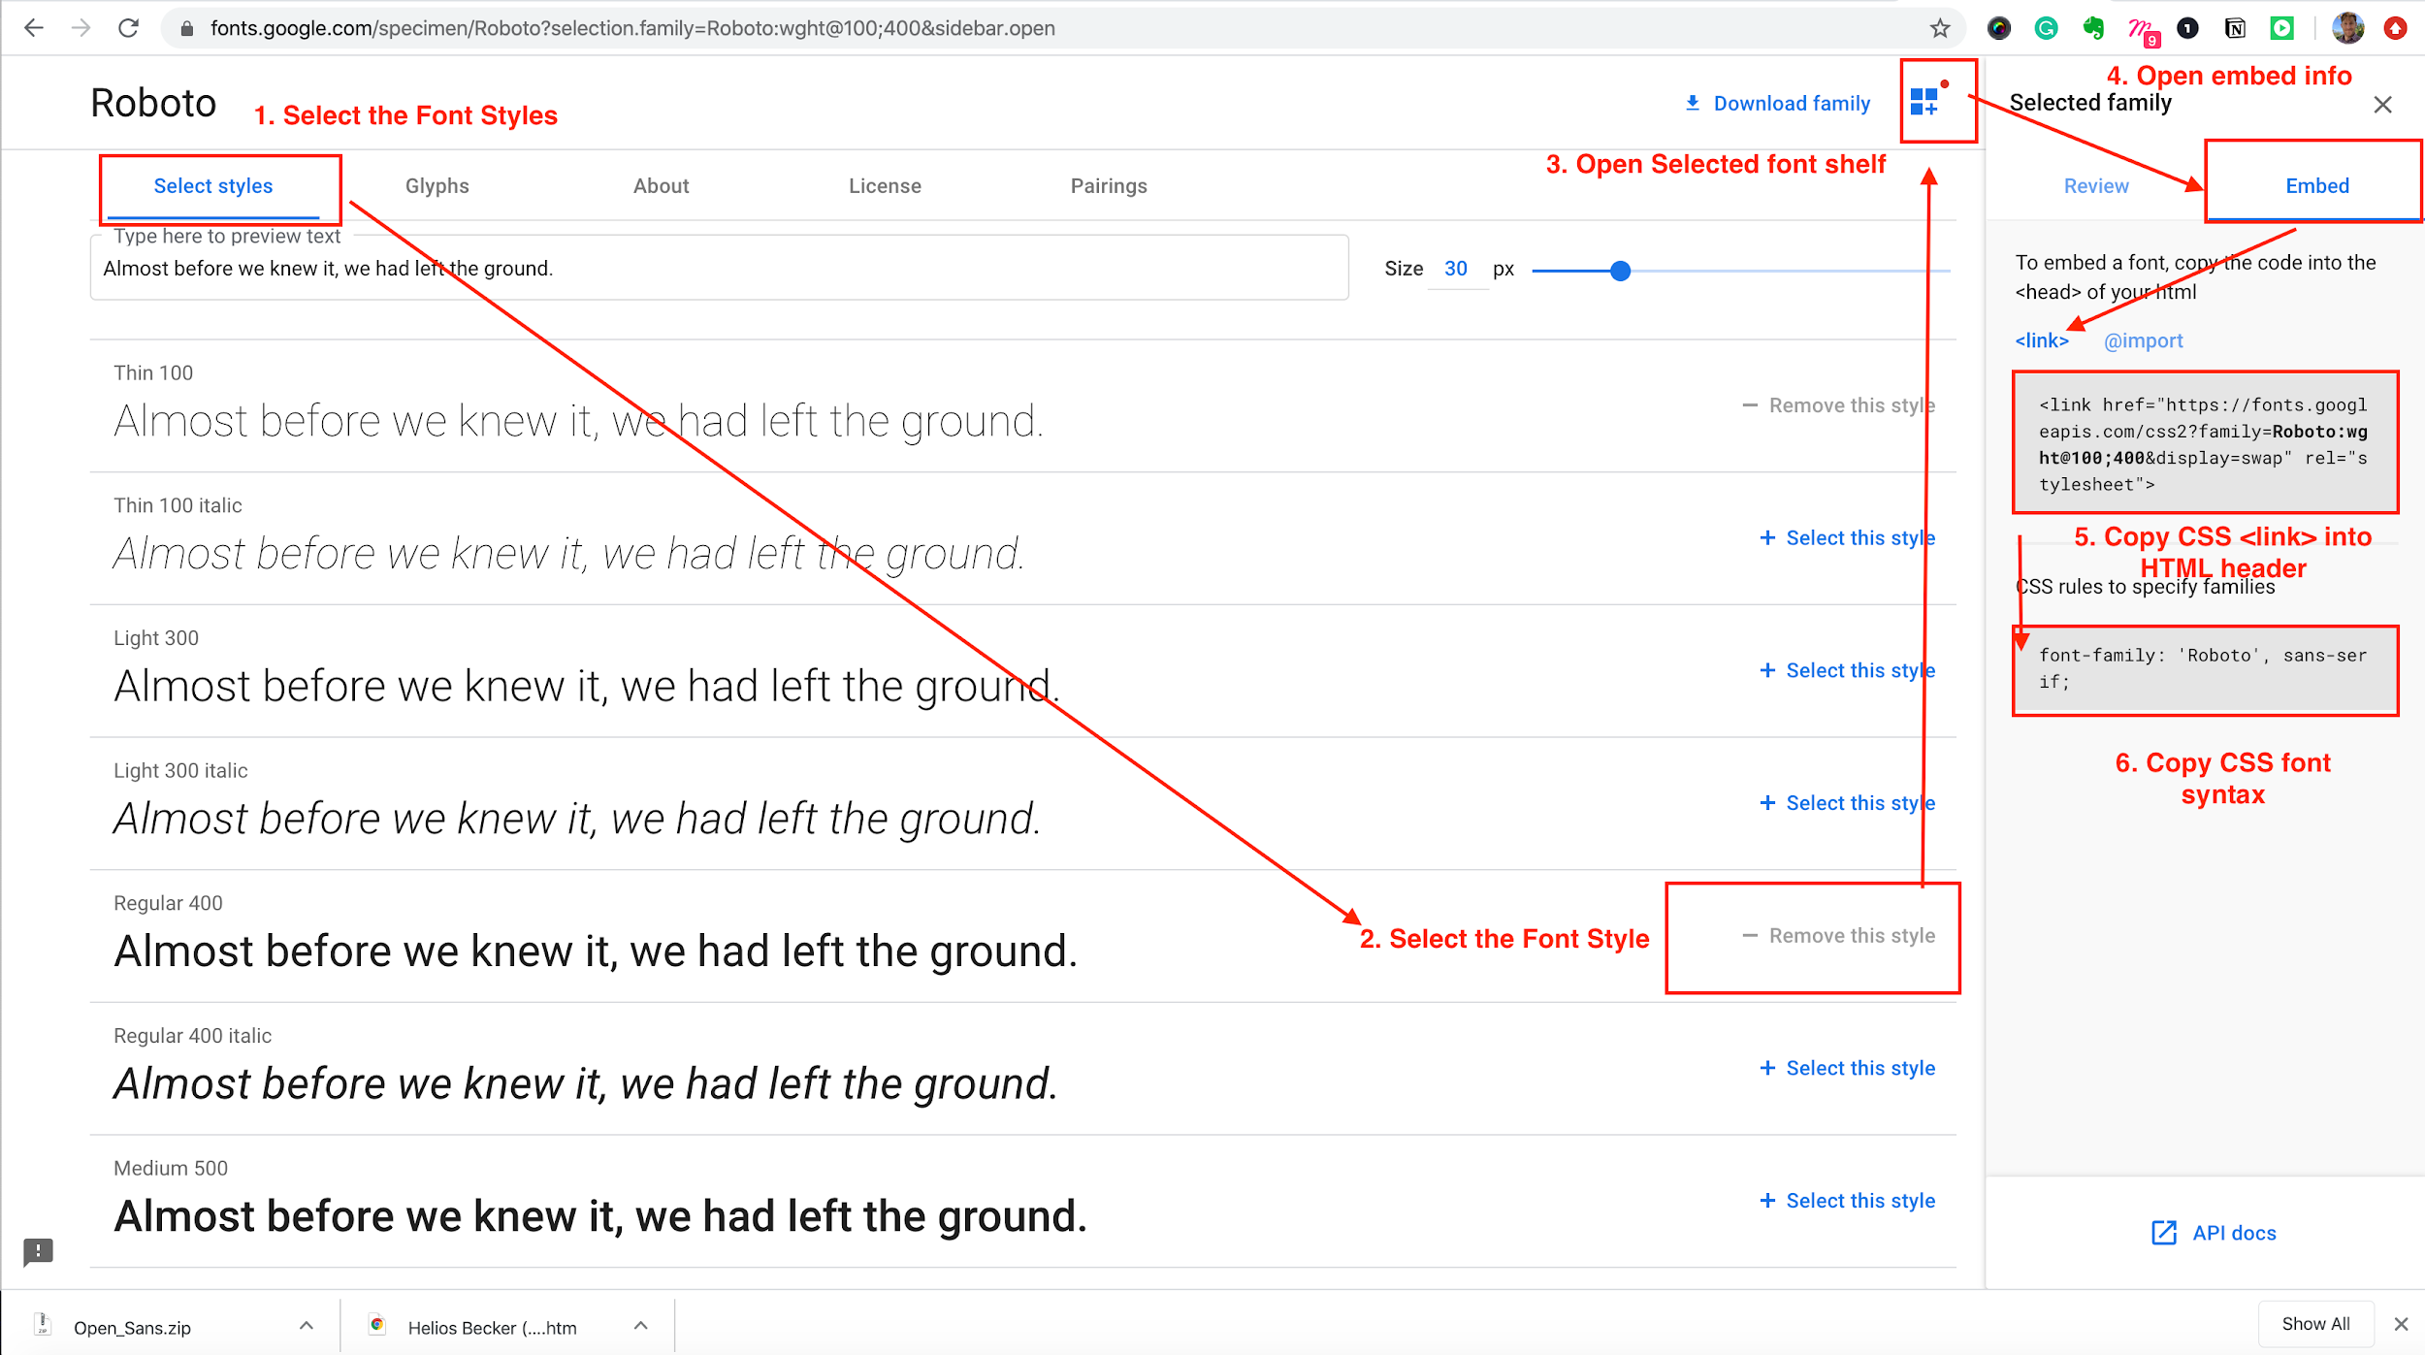

1. Copy the <link> tag and paste it above your custom CSS file in index.html.

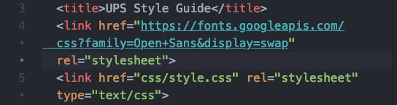

That’s it! You have now imported a custom font from Google Fonts into your webpage. You will be *adding* your font in the next section to our webpage.

**Part 2: Add Font Styles to Your CSS**

1. Open style.css from the .zip file.
2. Create a CSS selector at the top of the file that targets the base HTML element of the <body>.
3. Copy the font-family CSS property from Google Fonts, and add it to this selector.
   * This will apply the Open Sans font to any text within the <body> tag in index.html. It also has a fallback font, sans-serif, that will be used if the first font is unavailable or can’t be loaded for any reason.
4. Within the existing pageTopic selector, add the following properties:
   * font-size with the value of 14px;
   * font-weight with the value of 900;
5. Within the existing **Typography** section in index.css, add a selector that targets the large class and add the following properties:
   * font-size with the value of 66px;
   * margin-bottom with the value of 15px;
   * margin-top with the value of 0;
6. Create a selector that targets the light class, and add the following property:
   * font-weight with the value of 100;
7. Create a selector that targets the regular class, and add the following property:
   * font-weight with the value of 500;
8. Create a selector that targets the bold class, and add the following property:
   * font-weight with the value of 700;
9. Create a selector that targets all <h1> tags within elements with the typography class.
   * You can target elements within classes like so:

| .className element {   } |
| --- |

1. Add the following properties to this new selector:
   * font-size with the value of 50px;
   * font-weight with the value of 900;
2. Create a selector that targets all <h2> tags within elements with the typography class, and add the following properties:
   * font-size with the value of 42px;
   * font-weight with the value of 700;
3. Create a selector that targets all <h3> tags within elements with the typography class, and add the following properties:
   * font-size with the value of 34px;
   * font-weight with the value of 700;
4. Create a selector that targets all <h4> tags within elements with the typography class, and add the following property:
   * font-size with the value of 26px;
5. Create a selector that targets the button class, and add the following property:
   * font-size with the value of 14px;

That’s it! You have successfully completed your style guide. Refresh the page and see for yourself.